Latest Round-ups:
Season 2019/20
#20
Midweek Action: In the only game to beat the weather on Tuesday, Bridgwater’s second half fightback saw them defeat Wells City 3-1 in the Les Phillips Cup. The First Division side made a promising start, and took the lead after quarter of an hour, when Harvey Hadrill’s long-range effort nestled in the bottom corner. Bridgwater got back on level terms in the 58th minute, when Jake Llewellyn struck from the penalty spot, with the visitors then completing the turnaround a couple of moments later when Steve Murray smashed the ball in at the near post. Wells pushed for an equaliser, and came close on a couple of occasions, but were hit by a sucker-punch in the closing stages when David O’Hare struck to book Bridgwater’s spot in the quarterfinals.
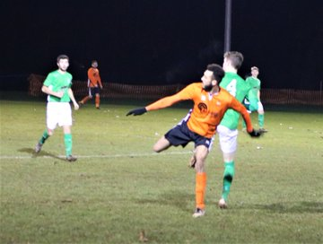
24 hours later, honours were even in Somerset, where Wellington and Street played out an entertaining 3-3 draw in the one Premier Division clash to take place under rainy skies. It was Wellington who struck first, going ahead after just nine minutes when Elliott Williams turned the ball home following a low cross into the area from Jake Horsey. The away side started to get into the game towards the end of the first half, and after Ollie Pearson equalised from the spot, Harry Gardner then rose highest to head them in front three minutes before the break. Within ten minutes of the restart, Wellington had turned the game on its head once more, with Harry Scratchard restoring parity, before home skipper Glen Wright headed home a couple of moments later. The final game of the contest came midway through the second half, with a strong finish from the edge of the box by Callum Thompson helping Street extend their unbeaten run. In Wednesday’s county cup fixtures, Corsham have reached the last four of the Wiltshire Senior Cup after defeating Downton 3-1. After surviving the afternoon pitch inspection, Corsham made an excellent start at the Southbank Ground, with Lewis McCarron putting them ahead after just five minutes. Downton then levelled the scores midway through the first half, but Corsham hit back instantly, and restored their advantage thanks to a headed effort from Ashley Alchin. The game remained in the balance for much of the second half, but then with ten minutes left on the clock, Corsham secured their passage through to the next round following a scrambled finish from Luke Curtis. There was also knockout success for Lebeq, with a 4-2 home victory over Hanham Athletic helping them reach the third round of the Gloucestershire Challenge Trophy.
Action from Wellington 3-3 Street
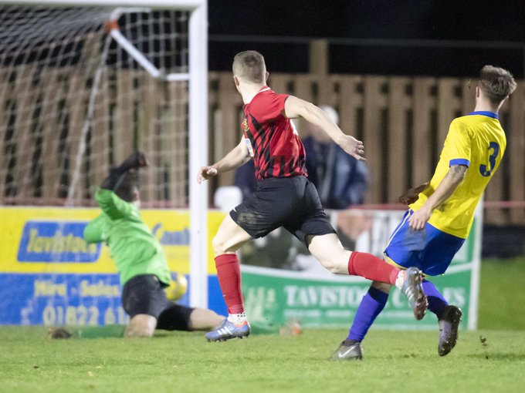
Premier Division: Exmouth Town continued their climb up the table on Saturday afternoon, dominating the first half on their way to a 3-1 victory away at Bridport. The Devon side now sit fourth, nine points off top spot with two games in hand, after a pair of goals from Jordan Harris and a strike from Mark Lever led them to a convincing win at St Mary’s Field. An injury time penalty helped Clevedon Town come from behind to defeat Roman Glass St George 2-1. After Troy Simpson had given Roman Glass a first minute lead, Clevedon were afforded the opportunity to level a couple of moments later, but Syd Camper blasted his penalty attempt over the bar. The Seasiders finally got the equaliser their performance deserved midway through the second half when top scorer Lucas Vowles found the back of the net. Then, with time almost up, Jay Murray was fouled in the visitors box, and Zach Drew took over penalty duties, and duly tucked the ball home to snatch all three points. There was also late drama at the Tannery Ground, where Harrison Kyte’s goal four minutes into stoppage time gave Bitton a last-gasp 1-0 victory over Street. In a top-seven clash, Shepton Mallet extended their winning run to three matches after overturning an early deficit on their way to a 3-1 away defeat of Hallen. The hosts have been in exquisite form themselves recently, and they forged ahead after half-an-hour, when Martin Stowell found the back of the net. Mallet weren’t behind for long however, and made it 1-1 just before the interval when Conrad Peck got his head on an Andy Martin corner. The turnaround was complete soon after the interval when Daryl Charman scored from close range, and then in the closing stages, Shepton wrapped up the victory thanks to a simple finish from Aaron Seviour. Bottom side Chipping Sodbury suffered a second half collapse, relinquishing a two-goal advantage on their way to a 4-3 defeat away at Tavistock. Leading by three goals to one early in the second half, the Sods were in position to climb up to 18th, but came unstuck, with Jordan Annear and Josh Grant scoring for the home side to bring the scores level, before Annear struck once again to hand the home side all three points. In Wiltshire, Harry Haughton’s long range effort led Cribbs to a 1-0 victory away at Westbury United.
Jordan Annear fires home Tavistock’s winner during their 4-3 comeback victory over Chipping Sodbury.

First Division: Sherborne Town returned to winning ways at home to Devizes, overcoming an early blip on their way to a comfortable home victory. After Devizes had earned a much-needed three points last Saturday, they made an excellent start at Raleigh Grove, with Rob Mitchell handing them a 7th minute lead following a fine one-two with Jordan Anning. The Zebras stormed back however, and following a brace from Josh Williams, plus further goals from Dan Newens and Joe Smith, they eventually ran out 4-1 victors. In the most dramatic ending on Saturday, Warminster somehow beat Portishead Town 2-1, scoring both of their goals after the 89th minute mark. The away side looked to have done enough to gain revenge on their 5-0 Les Phillips Cup defeat at the same ground earlier this season, with Callum Eastwood’s deflected effort putting them ahead on the 36 minute mark. With injury time on the horizon, Warminster were staring down the barrel, before being awarded a penalty which Ian Jeffrey fired home. Then, with both sides going all out for victory, the ball ended up in the Portishead area, and under pressure from their hosts, George Parsons inadvertently turned the ball into his own net to give Warminster a dramatic victory. Lebeq United were much too strong for Welton, with goalscoring doubles from both Shah Bhakerd and Cameron Brown leading them to a 4-1 victory, while Ross Padfield’s close range effort midway through the second half gave Wells a slim 1-0 win over Almondsbury.

Action from Shepton Mallet’s 3-1 victory over Hallen in the Premier Division, courtesy of John Pool.

PREMIER DIVISION LEADING GOAL SCORERS (League only):
Adam Carter (Plymouth Parkway) – 22
Jack Fillingham (Shepton Mallet) – 13
Lucas Vowles (Clevedon Town) – 13
Neikell Plummer (Bradford & Brislington) - 12
Gary Higdon (Bradford Town) – 11
Leighton Thomas (Street) – 11

FIRST DIVISION LEADING GOAL SCORERS (League only):
James Rustell (Radstock Town) – 17
Harry Foster (Wells City) – 14
Stuart Windsor (Calne Town) – 12
Adam Wright (Cheddar) – 10
Danny Carter (Longwell Green Sports) – 10
Toby Cole (Wincanton Town) - 10
*All goalscoring stats via Full-Time FA website
Latest Results
Tuesday 10th December 2019
Les Phillips Cup – Second Round
Wells City 1-3 Bridgwater Town 30
Wednesday 11th December 2019
Premier Division
Wellington 3-3 Street 42
GFA Challenge Trophy – Second Round
Lebeq United 4-2 Hanham Athletic 20
Wiltshire FA Senior Cup – Quarter Final
Corsham Town 3-1 Downton
Saturday 14th December 2019
Premier Division
Bridport 1-3 Exmouth Town 127
Clevedon Town 2-1 Roman Glass St George 105
Hallen 1-3 Shepton Mallet 83
Street 0-1 Bitton 50
Tavistock 4-3 Chipping Sodbury Town
Westbury United 0-1 Cribbs 96
First Division
Lebeq United 4-1 Welton Rovers
Sherborne Town 4-1 Devizes Town 105
Warminster Town 2-1 Portishead Town 133
Wells City 1-0 Almondsbury 47

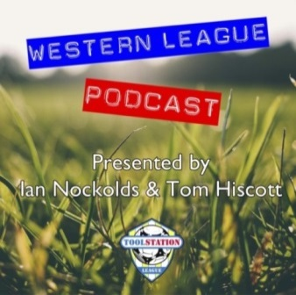
Be sure to check out the latest podcast, where Ian, Tom & guests recap all the latest news and results from around the Western League. To follow along all season, each broadcast will be available at the following link: http://www.toolstationleague.com/podcasts.php

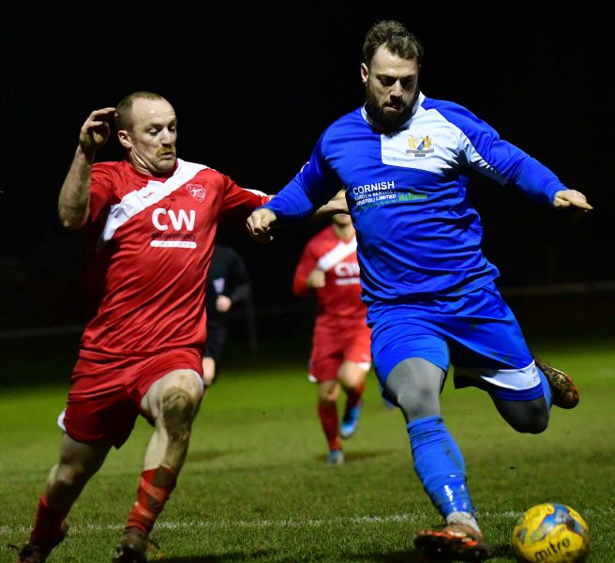
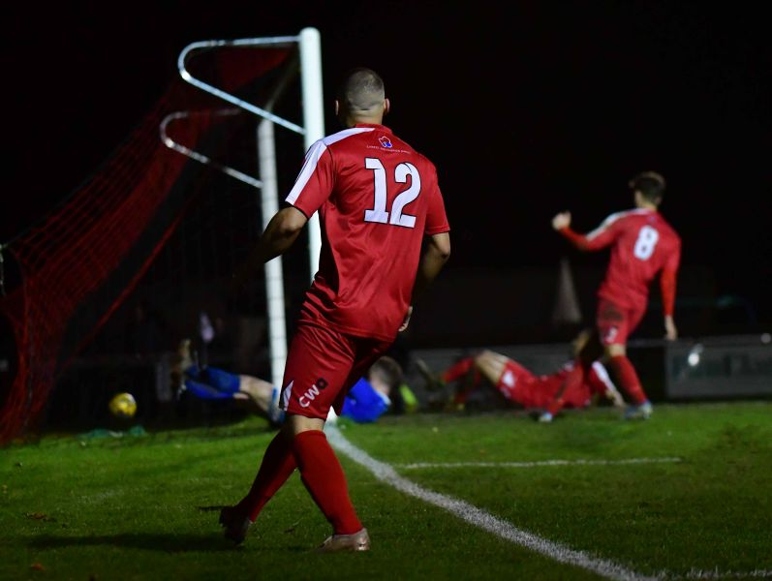

Recent action from Radstock Town’s 5-1 victory over Bishop Sutton, courtesy of John Newport
Upcoming Fixtures
Tuesday 17th December 2019
Premier Division
Keynsham Town vs Cadbury Heath 19:45KO
Street vs Clevedon Town 19:30KO
First Division
Wincanton Town vs Cheddar 19:30KO
GFA Challenge Trophy – Second Round
Almondsbury vs Bitton 19:30KO
Chipping Sodbury Town vs Tytherington Rocks 19:30KO
Longwell Green Sports vs Cribbs Reserves 19:30KO
Wednesday 18th December 2019
Premier Division
Plymouth Parkway vs Westbury United 19:30KO
Tavistock vs Bridgwater Town 19:45KO
First Division
Hengrove Athletic vs Portishead Town 19:30KO
GFA Challenge Trophy – Second Round
Bristol Telephones vs Brimscombe & Thrupp 19:45KO
Longlevens vs Hallen 19:45KO
Oldland Abbotonians vs Quedgeley Wanderers 19:45KO
Saturday 21st December 2019 (KICK OFF AT 3.00PM UNLESS NOTED)
Premier Division
Bitton vs Bridport
Bridgwater Town vs Brislington
Buckland Athletic vs Odd Down
Cadbury Heath vs Tavistock
Exmouth Town vs Plymouth Parkway
Hallen vs Street
Shepton Mallet vs Clevedon Town
Wellington vs Bradford Town
First Division
Almondsbury vs Calne Town
Ashton & Backwell United vs Bristol Telephones
Bishops Lydeard vs Bishop Sutton
Cheddar vs Lebeq United
Devizes Town vs Radstock Town 14:00KO
Portishead Town vs Sherborne Town
Warminster Town vs Oldland Abbotonians
Wells City vs Longwell Green Sports
Welton Rovers vs Hengrove Athletic
Wincanton Town vs Corsham Town
Les Phillips Cup – Second Round
Roman Glass St George vs Keynsham Town

League Tables
Premier Division
 |  | P | W | D | L | F | A | GD | PTS
1 | Bradford Town | 15 | 13 | 1 | 1 | 47 | 14 | 33 | 40
2 | Plymouth Parkway | 14 | 12 | 1 | 1 | 57 | 14 | 43 | 37
3 | Clevedon Town | 18 | 11 | 2 | 5 | 43 | 34 | 9 | 35
4 | Exmouth Town | 13 | 10 | 1 | 2 | 32 | 8 | 24 | 31
5 | Bridgwater Town | 16 | 9 | 4 | 3 | 44 | 22 | 22 | 31
6 | Hallen | 17 | 9 | 3 | 5 | 33 | 30 | 3 | 30
7 | Shepton Mallet | 16 | 9 | 2 | 5 | 35 | 25 | 10 | 29
8 | Bitton | 15 | 9 | 0 | 6 | 40 | 24 | 16 | 27
9 | Brislington | 20 | 8 | 3 | 9 | 31 | 50 | -19 | 27
10 | Tavistock | 13 | 8 | 2 | 3 | 39 | 20 | 19 | 26
11 | Westbury United | 18 | 7 | 3 | 8 | 33 | 28 | 5 | 24
12 | Street | 19 | 7 | 3 | 9 | 39 | 43 | -4 | 24
13 | Cribbs | 18 | 7 | 2 | 9 | 27 | 40 | -13 | 23
14 | Buckland Athletic | 15 | 7 | 1 | 7 | 25 | 27 | -2 | 22
15 | Cadbury Heath | 19 | 5 | 6 | 8 | 26 | 38 | -12 | 21
16 | Keynsham Town | 17 | 5 | 3 | 9 | 30 | 40 | -10 | 18
17 | Roman Glass St George | 15 | 5 | 2 | 8 | 33 | 22 | 11 | 17
18 | Bridport | 20 | 4 | 1 | 15 | 25 | 67 | -42 | 13
19 | Wellington | 19 | 3 | 2 | 14 | 20 | 51 | -31 | 11
20 | Odd Down | 16 | 3 | 1 | 12 | 15 | 38 | -23 | 10
21 | Chipping Sodbury Town | 19 | 3 | 1 | 15 | 23 | 62 | -39 | 10

First Division
 |  | P | W | D | L | F | A | GD | PTS
1 | Longwell Green Sports | 16 | 11 | 2 | 3 | 42 | 22 | 20 | 35
2 | Calne Town | 16 | 10 | 2 | 4 | 26 | 12 | 14 | 32
3 | Sherborne Town | 16 | 10 | 1 | 5 | 37 | 24 | 13 | 31
4 | Radstock Town | 14 | 9 | 1 | 4 | 39 | 23 | 16 | 28
5 | Wells City | 15 | 8 | 4 | 3 | 36 | 20 | 16 | 28
6 | Wincanton Town | 14 | 8 | 2 | 4 | 29 | 29 | 0 | 26
7 | Ashton & Backwell United | 16 | 7 | 5 | 4 | 26 | 30 | -4 | 26
8 | Cheddar | 16 | 7 | 4 | 5 | 29 | 25 | 4 | 25
9 | Warminster Town | 16 | 8 | 0 | 8 | 32 | 21 | 11 | 24
10 | Lebeq United | 17 | 8 | 0 | 9 | 37 | 37 | 0 | 24
11 | Oldland Abbotonians | 15 | 6 | 5 | 4 | 19 | 22 | -3 | 23
12 | Corsham Town | 17 | 7 | 2 | 8 | 28 | 41 | -13 | 23
13 | Bishops Lydeard | 14 | 6 | 2 | 6 | 31 | 24 | 7 | 20
14 | Welton Rovers | 17 | 5 | 4 | 8 | 20 | 32 | -12 | 19
15 | Portishead Town | 15 | 5 | 3 | 7 | 32 | 30 | 2 | 18
16 | Almondsbury | 16 | 5 | 3 | 8 | 23 | 29 | -6 | 18
17 | Devizes Town | 14 | 3 | 4 | 7 | 28 | 30 | -2 | 13
18 | Hengrove Athletic | 15 | 3 | 4 | 8 | 8 | 34 | -26 | 13
19 | Bishop Sutton | 14 | 2 | 2 | 10 | 18 | 30 | -12 | 8
20 | Bristol Telephones | 17 | 1 | 2 | 14 | 21 | 46 | -25 | 5

